Accuknox Assignment

Submission by :

Name : Vadlamani Uday Kumar

Contact : +91-7415366909

1. Django Signals are executed synchronously by default, which basically means that the signal handlers are executed immediately after the signal is triggered, in the same process and thread in which the code is executed.

**Snippets:**

Signals.py:

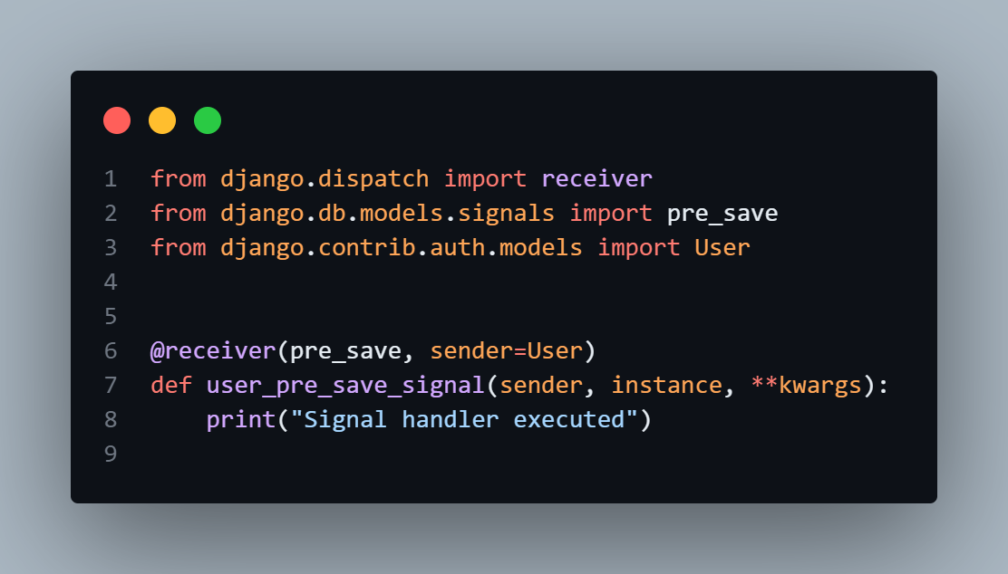

**Views.py**

**Urls.py:  
**

**The following outputs include :**

**Terminal :**

**HTTP Response :**

1. Yes, Django signals are handled synchronously, meaning that a particular signal is triggered and will be executed in the same thread.

**Snippets :**

**Signals.py  
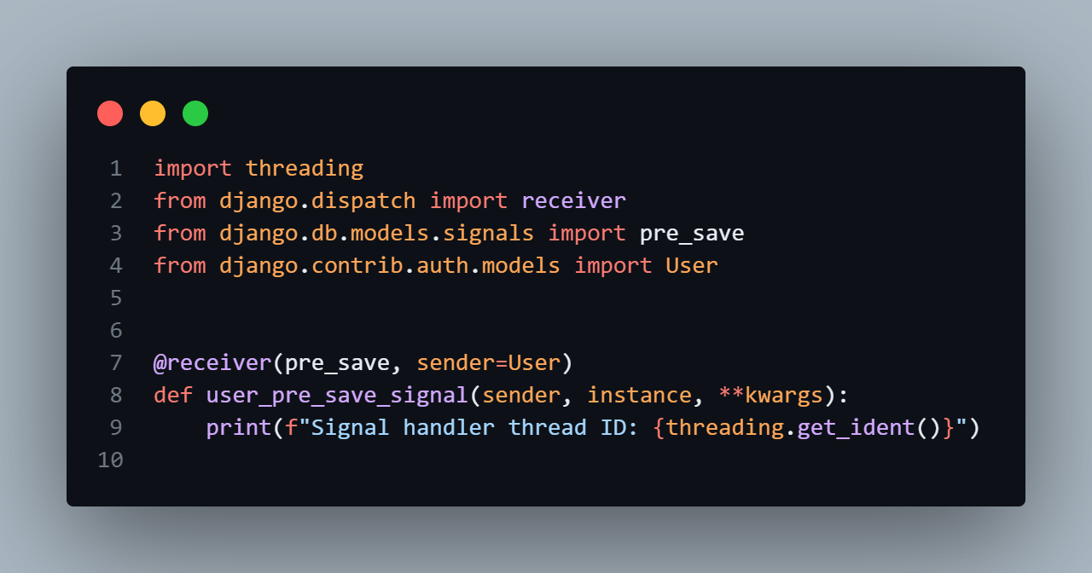**

**Views.py**

**Urls.py**

**THE FOLLOWING OUTPUTS INCLUDE :**

TERMINAL :

**HTTP RESPONSE :**

1. Django signals run in the same database transaction as the caller.In a database transaction the signal will be emitted and executed in the same thread.

**SNIPPETS :**

**Models.py**

**Signals.py:**

**Views.py   
**

**Admin.py   
**

**Output in :   
HTTP Response :**

**ADMIN :**

**CUSTOM CLASSES**

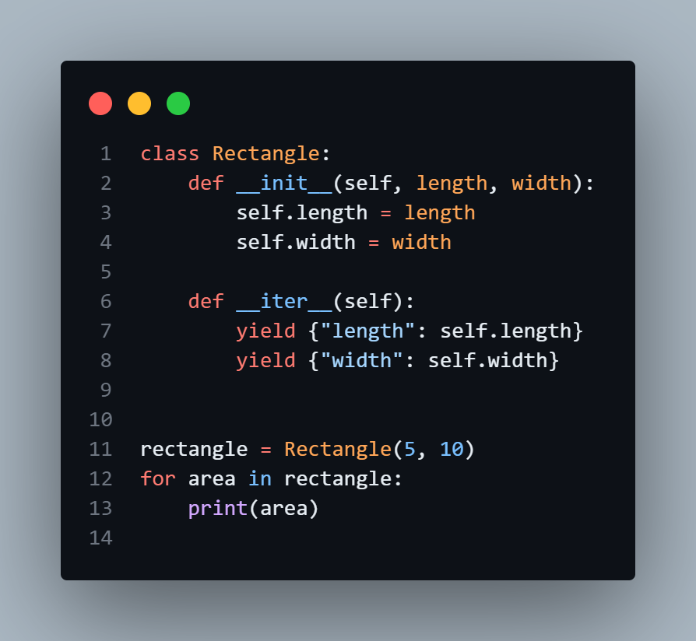

Output :

